**Petals to the Metal - Flower Classification on TPU**

Hemanth Raja Guttikonda, Poojitha Katta, Vamsi Krishna Popuri, Aishwarya Shankar and Kranthi Raj Vellanki

San José State University

Data 255: Deep Learning Technologies

Dr. Simon Shim

December 06, 2022

**Introduction**

Image classification is an important task in this day in age with many different applications for it. From anomaly detection to classification of images, image detection can be used for a wide variety of cases. With this demand there are many neural network models that can detect images and help classify objects within. Although there are many models, all these models are not created equally, therefore a lot of differences exist in the performance of these models.

The project that we have chosen is from the Kaggle hosted competitions, Petals to Metals. The objective of this project is to classify images of different flowers. With over 400,000 types of flowers that exist, in this project we will be focusing on 104 types of flower to classify. Images will consist of a single type of flowers each and as well as multiple types of flowers in one image. Building deep neural network models takes a really long time as it is a resource intensive task, therefore we will be utilizing the TPU’s to help make the training process more efficient. The TPU helps train a model at about five times faster than even using a GPU.

For our project we will be experimenting with five different models to compare the results of the different models and their effectiveness.

**Literature Review**

The purpose of TPUs is discussed by N. Jouppi et.al, and their performance on well-known neural network benchmarks is compared to that of GPUs and CPUs [1]. The Matrix Multiply Unit, commonly known as the brain of the TPU, was expressly built to execute Matrix Chain Multiplication of 2D arrays in O(n) time, which gives TPUs an advantage over other types of deep neural networks. Traditional methods, on the other hand, require O(n3) time to perform the same multiplication. To maximize its performance, the Matrix Multiply Unit is kept constantly active by the hardware components of the TPUs. ML applications like NLP, LSTM, and CNNs are used in the article to assess the performance of the TPU, Haswell CPU, and K80 GPU. When it comes to roofline performance, or TeraOps/Sec, TPUs surpass CPUs and GPUs.

Multiple papers we read as part of literature review are summarised in the below table.

**Table 1:**

*Literature review summary table*

| **Paper Name** | **Focus** | **Technology used** | **Evaluation metric** | **Reference** |
| --- | --- | --- | --- | --- |
| Inception-v3 for flower classification | Improving the accuracy of flower classification task | Inception-v3- Transfer learning | Accuracy= 95%, cross-entropy loss=.24 | [2] |
| Convolution Neural Network based Transfer Learning for Classification of Flowers | Comparison of CNN models with their respective transfer learning models | Transfer learning | Accuracy: VGG16 transfer- 85.53 (from 73% for VGG16), VGG19 transfer- 84.71 (from 58% for VGG19), Inception-v3-transfer -94.58% (from 82% ), ResNet50-transfer -95.29% (from 93% ) | [3] |
| An Image is worth 16x16 words: transformers for image recognition at scale | Using transformers for image segmentation and classification | CNN is used to extract feature map of images and this feature map is fed into transformers. | Accuracy:  ImageNet :88.55  ImageNet ReaL : 90.72  CIFAR-10 : 99.50  CIFAR-100 : 94.55 | [4] |
| Swin Transformer: Hierarchical Vision Transformer using Shifted Windows | Updating model existing vision transformer. Uses Image segmentation detection for classfication onf images. | Has similar architecture of vision transformers, in the end it has 2 successive swim transformer blocks. | Accuracy:  ImageNet top1 :81.3  ImageNet top5 : 95.6 | [5] |

**Related Work**

Conventionally, flower classification is done based on three features: shape, texture and color [2]. However, in traditional classification methods, the feature selection for flowers is manual. The development of convolutional neural networks paved the way for automatic feature selection from images without the need for complex pre-processing tasks. Transfer learning using pretrained models gave comparatively better results for multiclass image classification tasks.

[6] E.Cengil et.al, uses Transfer Learning for classifying flowers into multiple classes. The focus of the paper was to study the use of pretrained models for classification. AlexNet, VGG16, DenseNet201, GoogleNet and ResNet were the models used. A five class flower dataset from Kaggle with each class consisting of about 800 pictures was used as the dataset. The models were pretrained on the ImageNet dataset which consists of 1000 classes. The models gave good performance with VGG16 giving the highest accuracy of 93.52%.

[7] Chen et al. used Inception-Resnet model for classification CT scans of covid-19 patients. The dataset used consists 3 types CT scan images from Jinyintan hospital. Thedataset include normal CT scans, Mild covid-19 symptoms, severe COVID-19 symptoms. They used Inception-Resnet v.2 and intially trained it with imagenet dataset. Inorder to improve the classification accuracy they introduced self attention mechanism, here they converted all the features from output feature map into a feature vector using global average pooling. They used the image data(64*64) along with 3D volume data of CT scan (48*48*9) in modeling. Their model has accuray of 80.60, Recall 82.67 and Precision of 79.96.

**Data Exploration**

The data is in .tfrecord format. The dataset contains 12753 training, 3712 validation and 7382 test images. The images are of high dimension and in large quantities and normal CPUs and GPUs fail to process these images. These are only processed on a TPU.

**Figure 1:**

*Raw dataset in .tfrec format*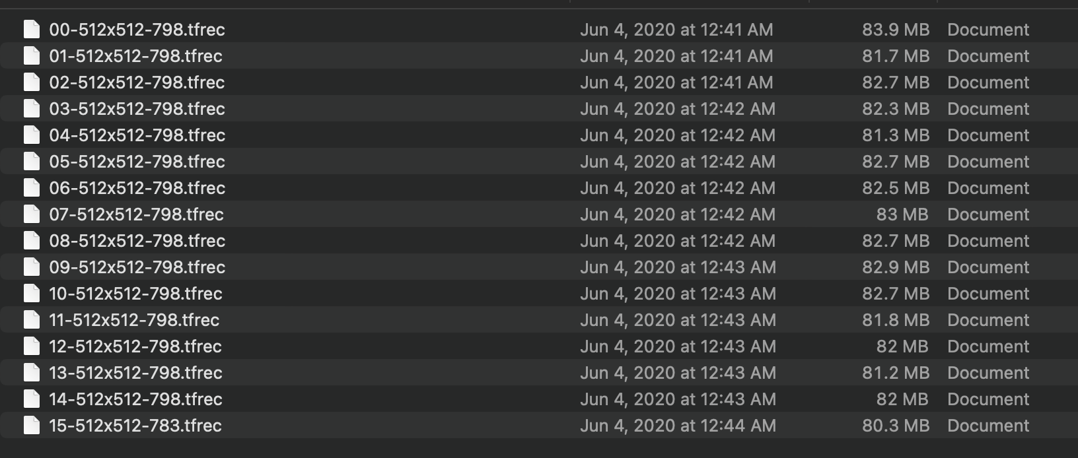

**Figure 2 :**

*Showing data split in train, validation and test datasets*

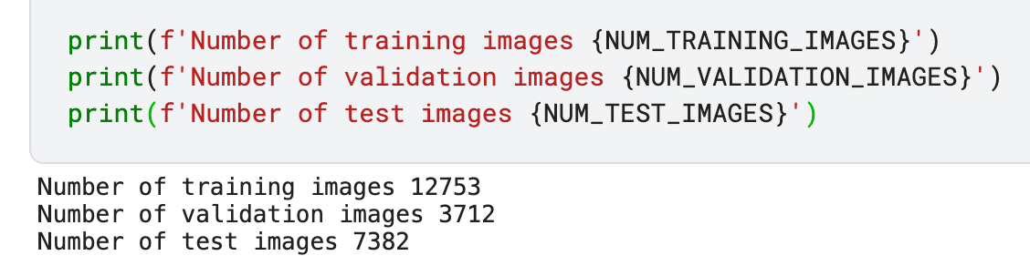

The training dataset consists of 12753 images with 104 classes. We observed the label frequency in the training data. The mean frequency of the training images is 123 images per class. The dataset is imbalance and this can be observed from the boxplot of classes vs frequency. The training data with highest frequency is ‘iris’ with 782 images, there are classes with training data as low as 18.

**Figure 3:**

*Showing the statistics of training data frequency.*

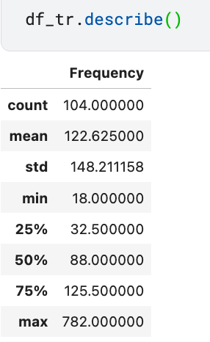

**Figure 4:**

*Showing top 5 labels with highest frequency.*

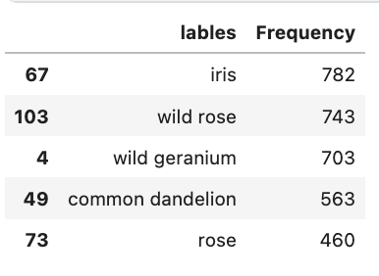

**Figure 5:**

*Showing the bargraph of different classes and frequency in training data.*

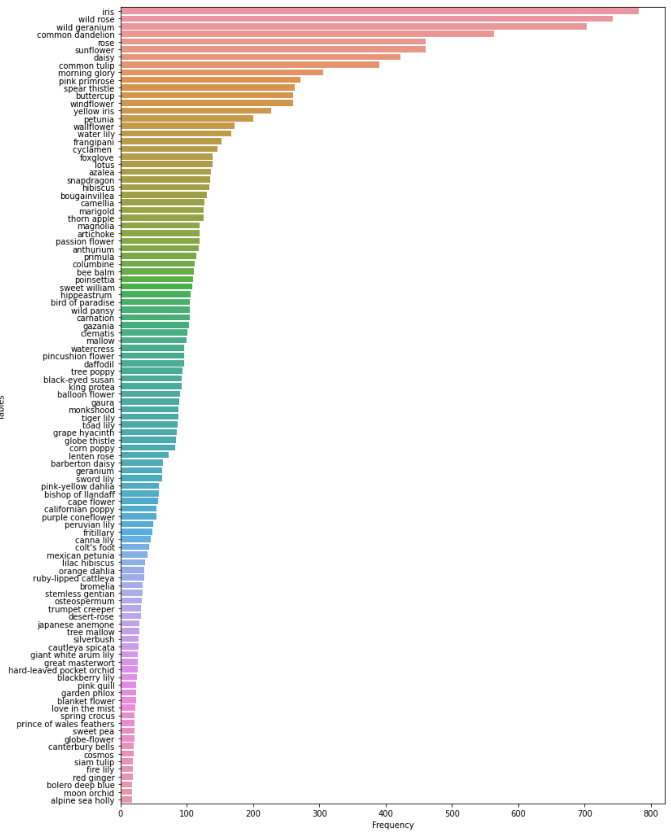

**Figure 6:**

*Displaying 20 images from training data.*

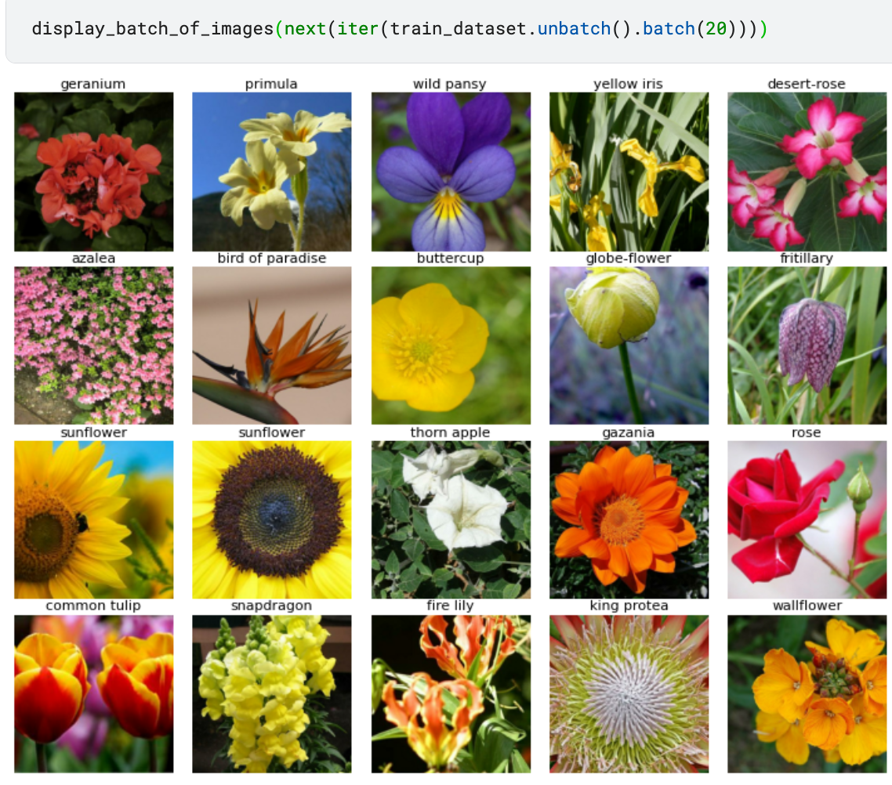

The validation dataset consists of 3712 images and 104 classes. There are validation images for every class present in the training dataset. This shows us the dataset split is optimum. The dataset has the similar distribution as the training dataset. We can observe the data frequency of validation dataset is almost similar to training data. The graph of frequency vs classes are identical.

**Figure 7:**

*Showing the statistics of validation data frequency.*

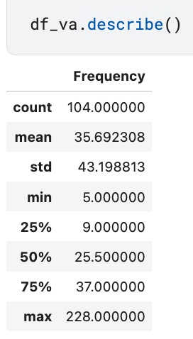

**Figure 8:**

*Showing top 5 labels with highest frequency.*

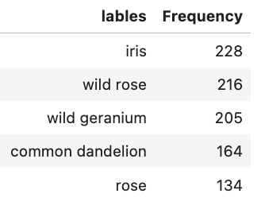

**Figure 9:**

*Displaying 20 images from validation data.*

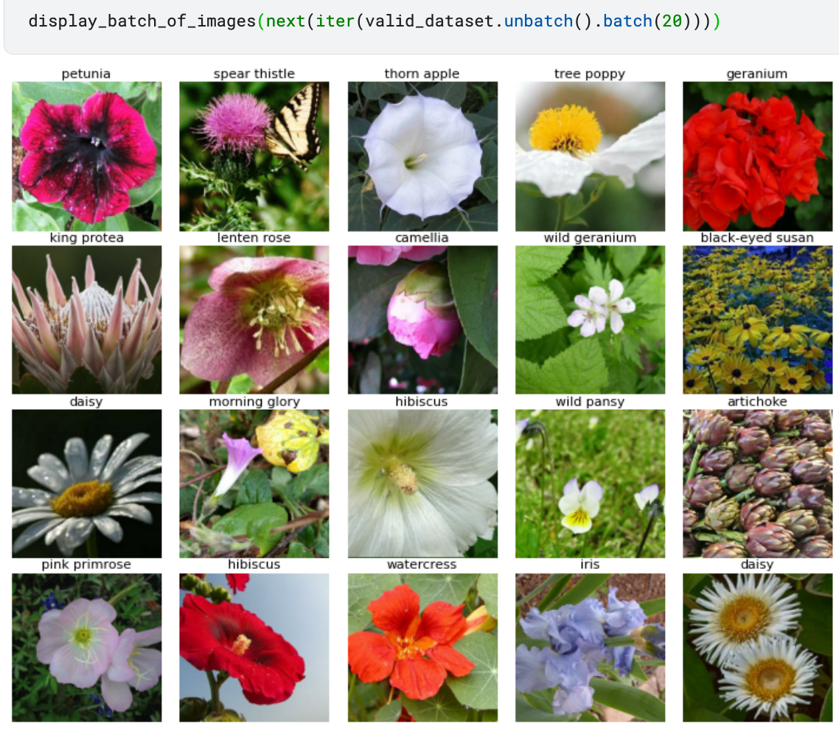

**Figure 10:**

*Showing the bar graph of different classes and frequency in validation data*

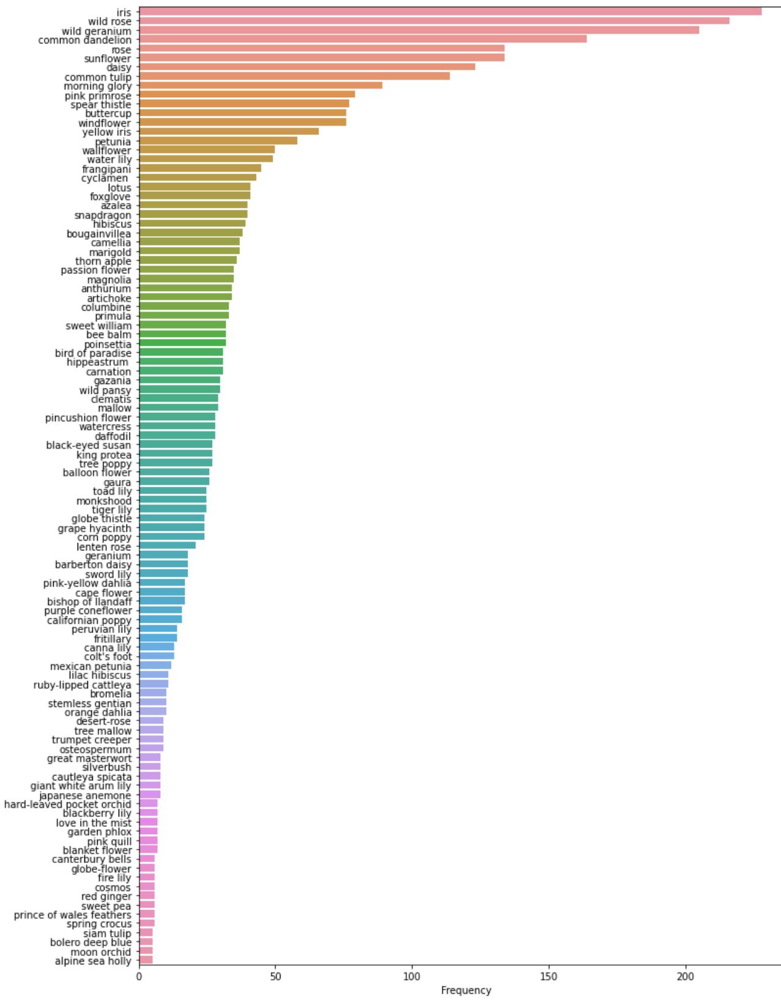

Testing data consists only of images. These images have a similar shape to that of training data. We do not have any information about the test labels.Using the prediction on the test data, we create a prediction file of specified format. This file is submitted to the kaggle website, the website gives the accuracy for the submitted file.

**Figure 11:**

*Displaying 20 images from testing data.*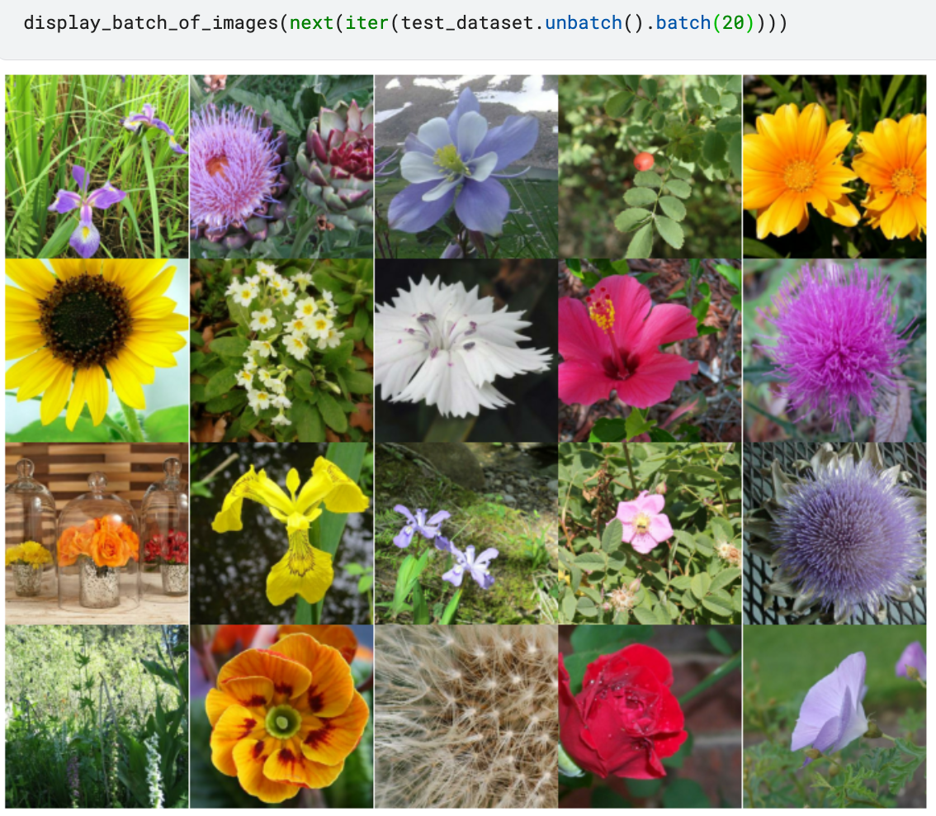

**Data Processing**

The Images chosen here are in the form of .tfrec with different sizes like, 192 x 192, 224 x 224, 331 x 331 and 512 x 512. These sizes help in extracting features which are relevant and easy to be processed by huge network heavy architectures. Image size is important for Image Classification tasks because the bigger the size, the more parameters the network will have to deal with. More parameters will need more computational power.

Data Augmentation in this project is very important because to extract the objects in an image, like say a 512 x 512 image, we can resample it to 256 x 256 and get smaller patches. Thus, all the sizes of input data helps in making use of patches and can be used efficiently by the network architectures.

**Figure 12:**

*Input dimensions and size.*

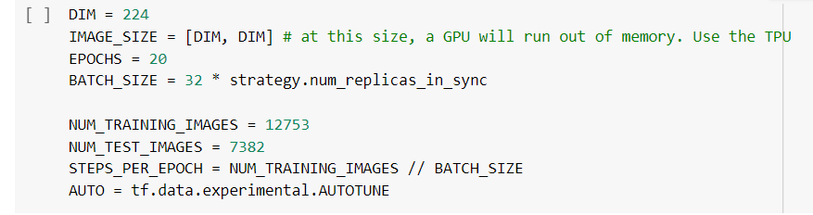

Thus the image data is considered in different patch sizes. They are further divided into batches based on the number of Replicas the TPU cluster has. Higher size and fewer device drivers will result in a computational heavy approach to perform this classification task. Memory issues may come into play and more resources will be needed to ensure smooth execution.

**Data Processing Flow**

The images are collected and then segregated into train, test and validation. The competition provides test images without labels.

The process starts with segregating the images with labels and without labels using map function. The ones with labels are classified as training dataset and validation dataset. The one without labels will form the test dataset.

All the images are then augmented using different augmentation techniques like, decoding the image into 3 channels, random flip, random saturation, random blockout etc.

The following presents samples from data augmentation:

**Figure 13:**

*Random Blockout*

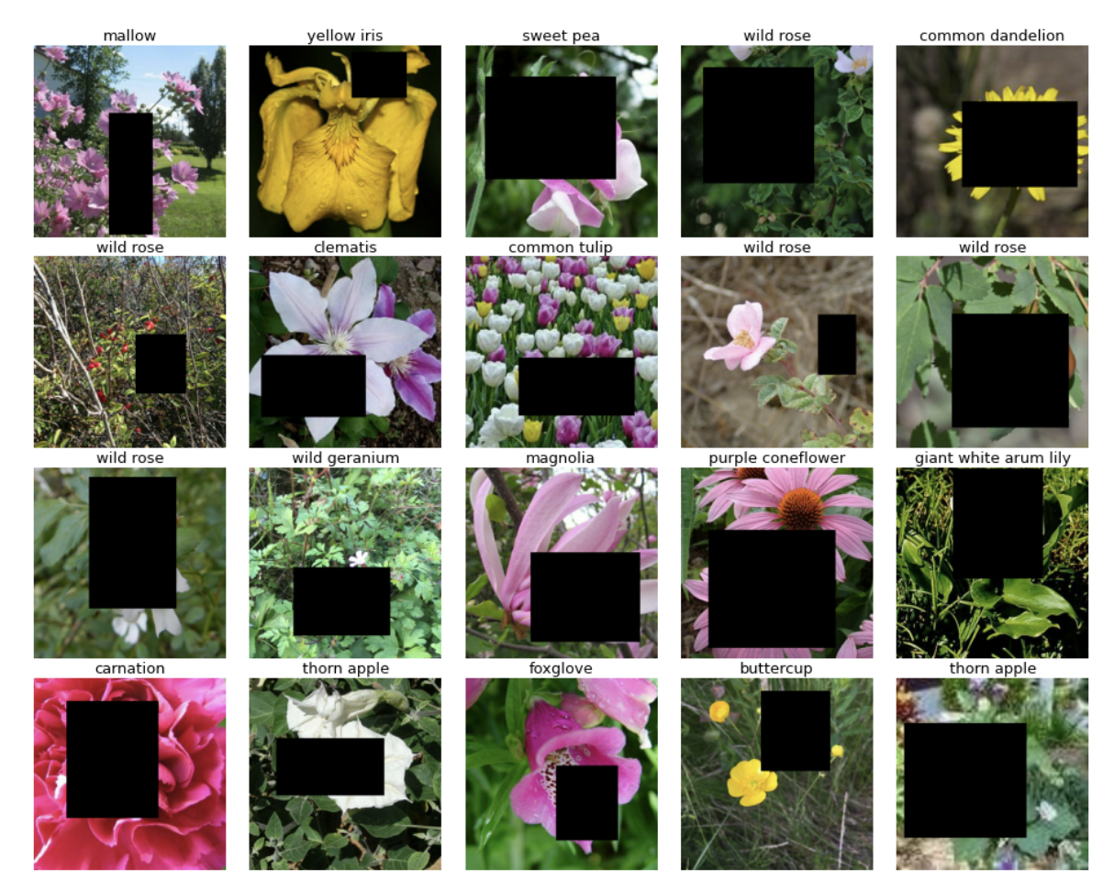

The final shape of the image after flattening with linear embedding, that is used for modeling is as follow:

**Figure 14:**

*Final Dataset*

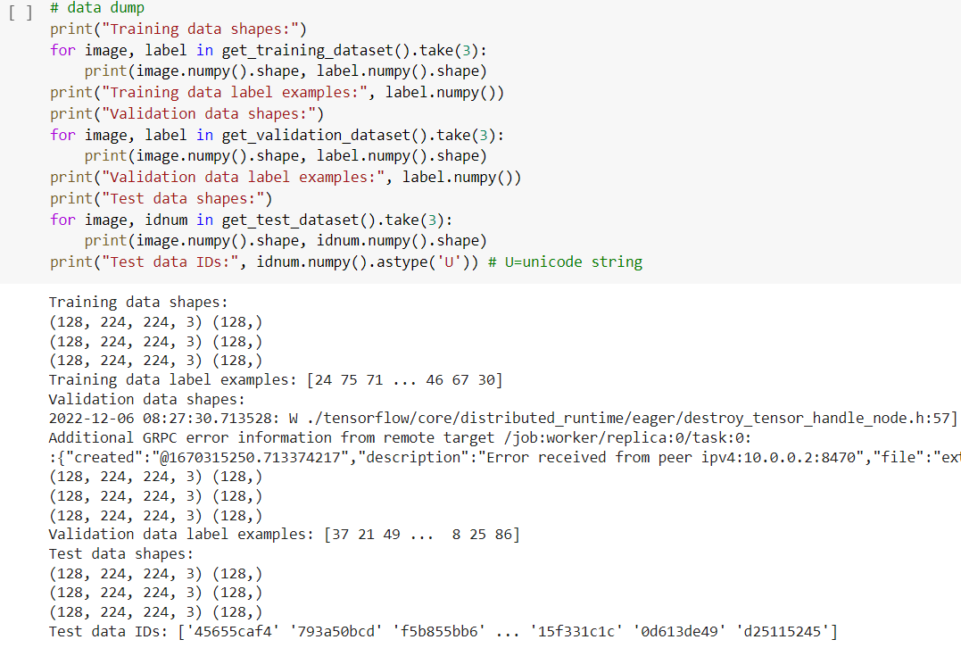

**Problem Formulation**

In this competition we're classifying 104 types of flowers based on their images drawn from five different public datasets. Some classes are very narrow, containing only a particular sub-type of flower (e.g. pink primroses) while other classes contain many subtypes (e.g. wild roses).

This competition is different in that images are provided in TFRecord format. The TFRecord format is a container format frequently used in Tensorflow to group and share data files for optimal training performance. Each file contains the id, label (the class of the sample, for training data) and img (the actual pixels in array form) information for many images.

The images consist of both, single flowers and a group or bunch of flowers, stating the real scenario of classification as there are a massive number of flower categories. This competition helps when the number of class labels are many.

Handling of image data is tedious, time consuming and computationally heavy. We are trying to solve the problem of handling image data in less time using TPUs. Heavy architectures need lots of drivers to process the data but it takes a lot of time. With the help of TPU, we can solve this problem and actually address a large-scale classification problem with ease.

**Model Selection**

1. **Transfer Learning using CNN [8]**

CNN is a popular neural network model that helps with feature extraction from training data provided. The features are extracted through the use of convolutional layers which the images pass through as a part of the training for the model. The training process accuracy and speed can be increased by using available pre-trained models which can be fine tuned to fit our specific use case of classifying the various types of flowers in our training dataset.

The CNN model first starts off by using a data augmentation layer which randomly flips the image in a random direction. From here the image is passed into our convolutional layer with pretrained weights. The pretrained model that I am specifically using for my model is the Imagenet pretrained model which has pretrained weights specifically for image data. Here the model is able to fine tune the pretrained model specifically for our use case of classifying flowers, and learns about which flower is which. After the image passes through the convolutional layer, the image is then taken as input into the average pooling layer where the image is downsampled. The image is downsampled here so that when classifying the image it will become much easier to classify. The averaging layer pool takes the average of an area and sets the area to that average. After the image has been downsampled, the image is then passed into the dense layer where the image is then classified based on the weights that model has defined. If the image is classified correctly nothing happens to the weights, but if the weights are not classified correctly, the weights will be updated.

The loss used for the model is sparse categorical cross entropy as this is one of the best loss functions to use when we have a multiclass classification problem as with our petals to metal problem. The activation function used was the softmax function, as it helps better interpret the outputs by making the outputs a vector of probabilities. Additionally TPU was used to train the model as it helps drastically reduce the training time for the models, by giving extra compute power for the models to make the training process easier.

With this model the accuracy score we were able to achieve was about 99%. Once the model was used to predict the test data, a F1 score of about 92% was achieved for the Transfer Learning CNN model. This score puts us at about thirty third position in the Kaggle competition, meaning thirty two people have a better model that can predict more accurately.

This is one of the better models that we have tested and this due to being a fine tune model. Using the pretrained model has given us a big jump in accuracy with less training since the base model training has been done, which helped our model perform better with less training. The fine tuning steps that have been done using CNN has helped train the model for classification of our 104 types of flowers as mentioned above.

1. **Vision Transformer[9]**

The Vision Transformer is the state-of-the-art for image recognition tasks in computer vision, outperforming CNN by almost 4 times in terms of efficiency, accuracy and ease of use. The vision transformer which is developed by the Google Research Brain Team, uses something called multi-headed self-attention that concatenates all the attention that it linearly computed, to its respective dimensions. The multiple attention heads helps in tracking the local and the global dependencies. The Multi-Layer Perceptron (MLP) has two Gaussian Error Linear Units (GELU). The Layer Norm is added prior to each block that helps in training with ease without involving dependencies between training images. The training is further improved using the residual connections between each block.

**Figure 15:**

*Vision Transformer Architecture*

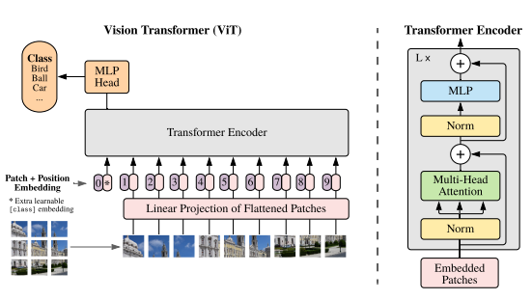

The architecture of ViT starts with splitting of the images into fixed sizes. They are called patches. These patches are then flattened to create a lower dimension linear embedding flow. Positional embeddings are added to these later, and then fed into the state-of-the-art encoder transformer. The ViT model is then pre-trained with image labels that is already fully supervised on a big dataset. Fine-tuning this for necessary context application will further help in task completion.

The use of vision transformers in common image recognition tasks like object detection, image segmentation, picture classification, and action recognition is widespread. Additionally, ViTs are used in multi-model tasks such as visual reasoning, visual question answering, and generative modeling. All aspects of video processing that call for ViT include video forecasting and activity detection. ViT models are also used in picture augmentation, colorization, and super-resolution. Last but not least, ViTs have several uses in 3D analysis, including point cloud categorization and segmentation.

1. **SWIN Transformer [5]**

The Swin Transformer (Shifted Window Transformer) can act as the computer vision industry's backbone. The representations of the hierarchical Swin Transformer are computed using shifted windows. By confining self-attention computation to non-overlapping local windows while still allowing for cross-window connections, the shifted window technique improves efficiency. This design has a linear computational complexity with respect to image size and the ability to model information at multiple scales.

**Figure 16:**

*Swin Transformer Architecture*

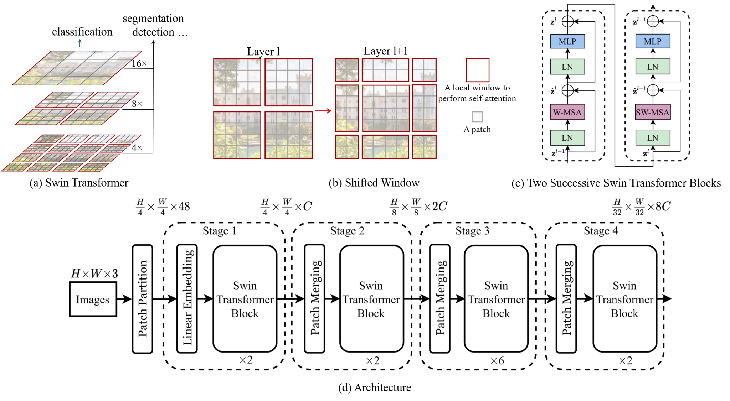

The "Patch Merging" block and the "Swin Transformer Block" are the two main components of Swin Transformer, as can be seen from the design. In Swin Transformer, "hierarchical feature maps" are created. These hierarchical feature maps have the same spatial resolution as ResNet. This was done on purpose so that ResNet backbone networks in current vision task approaches might be easily replaced by Swin Transformers. The Swin Transformer can be used in situations where fine-grained prediction is necessary, like semantic segmentation, thanks to these hierarchical feature maps.

Using hierarchical feature maps and shifted window MSA, the Swin Transformer resolved the issues that plagued the original ViT. Today, the Swin Transformer is commonly used as a backbone architecture in a broad range of vision tasks, including image classification and object detection

1. **ResNet [10]**

Residual Networks, or ResNets, learn residual functions with reference to the layer inputs, instead of learning unreferenced functions. Instead of hoping that each few stacked layers directly fit a desired underlying mapping, residual nets let these layers fit a residual mapping. They stack residual blocks on top of each other to form a network: e.g. a ResNet-50 has fifty layers using these blocks.

**Figure 17:**

*ResNet - 34 Architecture*

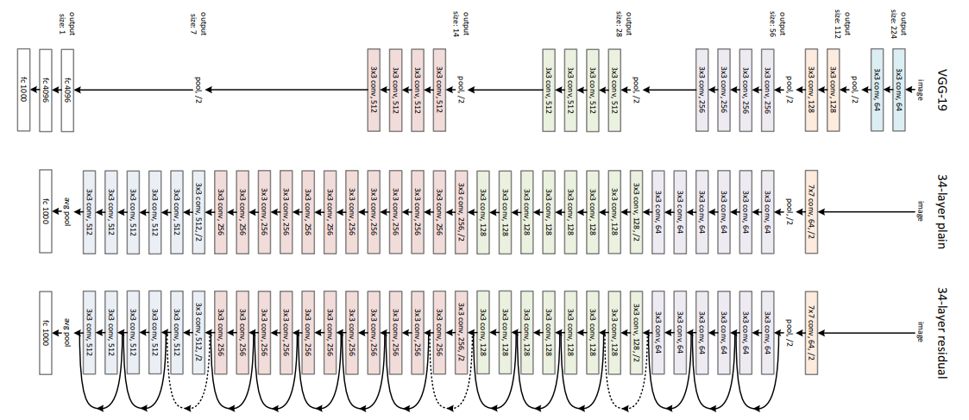

1. **DenseNet [11]**

One of the most recent advancements in neural networks for visual object detection is DenseNet. ResNet and DenseNet are relatively similar, however there are several key distinctions. While DenseNet concatenates (.) the output of the previous layer with the output of the subsequent layer, ResNet utilizes an additive approach (+) that merges the previous layer (identity) with the subsequent layer.

**Figure 18:**

*DenseNet Architecture*

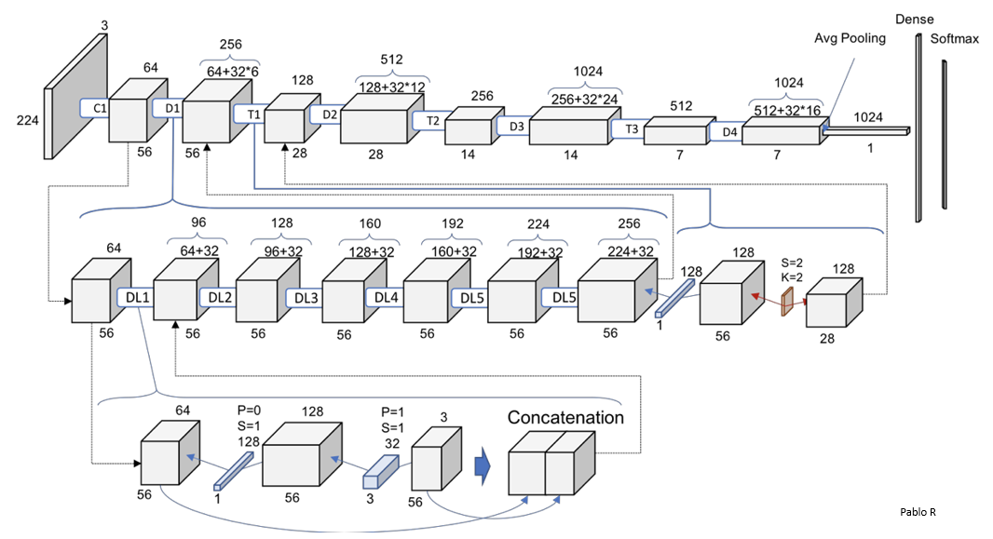

By applying the composite function operation, an output from the first layer serves as an input for the second. The convolution layer, pooling layer, batch normalization, and non-linear activation layer make up this composite operation. The network has L(L+1)/2 direct connections as a result of these linkages. L is the number of architectural layers. There are various variations of the DenseNet, including DenseNet-121, DenseNet-160, and DenseNet-201. The numerical values represent the neural network's layer count.

1. **EfficientNet [12]**

To improve accuracy and efficiency in a much more moral manner, Tan, M, et.al, suggested scaling up CNN models. To scale up models in a quick and easy way, EfficientNet use a method called compound coefficient. Compound scaling uniformly scales each dimension with a predetermined fixed set of scaling coefficients as opposed to randomly increasing width, depth, or resolution. The developers of efficient created seven models in different dimensions using the scaling approach and AutoML, outperforming most convolutional neural networks' state-of-the-art accuracy while operating far more effectively.

**Figure 19:**

*EfficientNet B7 Architecture*

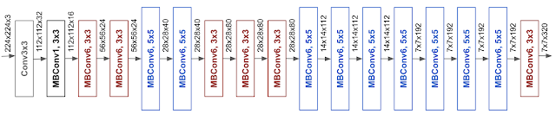

The architecture for our baseline network EfficientNet-B0 is simple and clean, making it easier to scale and generalize.

The baseline network has a significant impact on how well models scale. A new baseline network by conducting a neural architecture search using the AutoML MNAS framework, which maximizes both accuracy and efficiency, in order to further increase performance (FLOPS). Due to a greater FLOP budget, the resulting architecture uses mobile inverted bottleneck convolution (MBConv), which is similar to MobileNetV2 and MnasNet. The baseline network is then scaled up to create the EfficientNets family of models.

1. **Xception [13]**

Xception, stands for Extreme version of Inception, is reviewed. With a modified depthwise separable convolution, it is even better than Inception-v3 for both ImageNet ILSVRC and JFT datasets.

**Figure 20:**

*XceptionArchitecture*

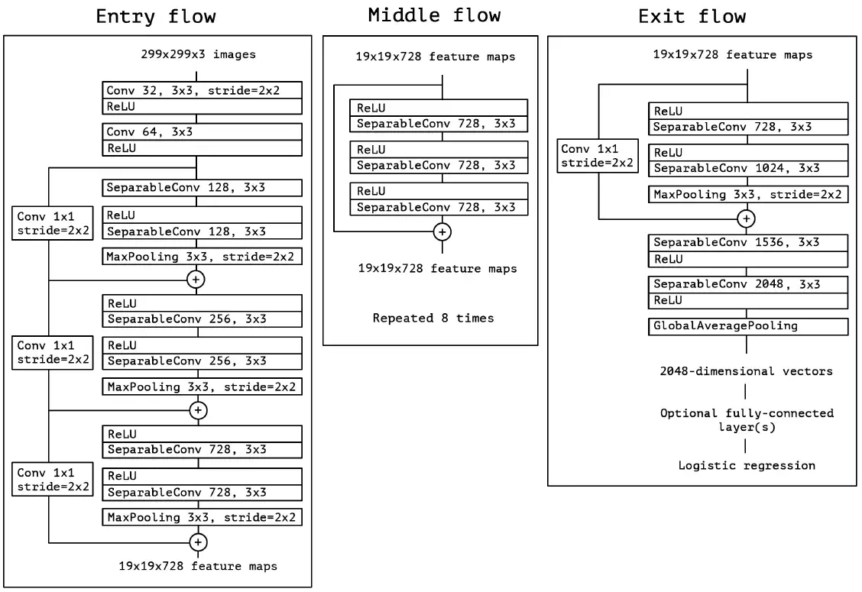

SeparableConv is the modified depthwise separable convolution, as seen in the previous figure. We can see that SeparableConvs are used throughout the entire deep learning architecture and are handled as Inception Modules. Additionally, all flows have residual connections, which were first put forth by ResNet.

1. **Inception-ResNet [14]**

The Inception module was conceived as an efficient deep neural network architecture for computer vision tasks. The module was developed to significantly increase the depth of the deep neural networks. The major drawbacks with increasing the depth of a neural network are proneness to overfitting and increased use of computational resources [11]. Inception module is a technique to effectively scale up of convolutional neural networks using factorized convolutions and aggressive regularizations.

**Figure 21:**

*Inception Architecture*

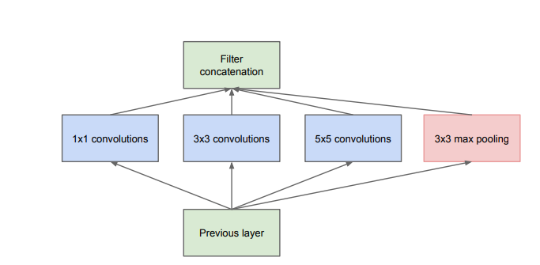

A Inception-ResNet module is a combination of both the modules. It is seen that training an Inception module with residual connections accelerates the training of the former significantly [13]. Also, the network is seen to give improved performance over the conventional Inception modules. These advantages of faster training and better prediction performance motivated us to try the Inception-ResNer-v2 module for our project.

**Figure 22:**

*General schema of an Inception-ResNet-v2 module*

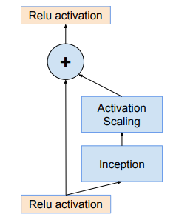

1. **Ensemble Method**

Neural networks for deep learning are nonlinear techniques. They provide more flexibility and can scale in line with the quantity of training data that is available. They learn using a stochastic training procedure, which means that they are sensitive to the particulars of the training data and may find a different set of weights each time they are trained, leading to different predictions. This flexibility has a drawback.

When trying to create a final model to utilize for making predictions, this is commonly referred to as neural networks having a high variance and it can be irritating. By training numerous models instead of just one, and combining their predictions, neural network models can successfully reduce their variance. This process, known as ensemble learning, not only lowers the variance of predictions but also has the potential to produce predictions that are superior to those produced by a single model.

**Model Evaluation**

**F1-Score**

The task is to predict the correct labels for each of the images in test set. So, we used F1-score as our evaluation metric. This is also the evaluation metric used by Kaggle in ranking the submissions. The F1-score combines the precision and recall of a classifier into a single metric by taking their harmonic mean. It is primarily used to compare the performance of two classifiers. Suppose that classifier A has a higher recall, and classifier B has higher precision. In this case, the F1-scores for both the classifiers can be used to determine which one produces better results. The F1-score of a classification model is calculated as follows:

2*(P*R) / (P+R)

P = the precision , R = the recall of the classification model

**Loss:**

Loss is the penalty for a bad prediction. That is, loss is a number indicating how bad the model's prediction was on a single example. If the model's prediction is perfect, the loss is zero; otherwise, the loss is greater. The goal of training a model is to find a set of weights and biases that have low loss, on average, across all examples.

**Sparse Categorical Accuracy:**

sparse_categorical_accuracy is similar to categorical_accuracy but mostly used when making predictions for sparse targets. This task produces a situation where the yTrue is a huge matrix that is almost all zeros, a perfect spot to use a sparse matrix. For sparse categorical metrics, the shapes of yTrue and yPred are different. This checks to see if the maximal true value is equal to the index of the maximal predicted value.

**Result Analysis and Visualizations**

All the results were analyzed based on the F1-Score. The accuracy of all the models in every case is more than 95%. Only the F1-Score varies each time.

***Version 1 (Xception):***

The first version is just a pretrained Xception model using imagenet weights.

The F1-Score is 0.611.

***Version 2 (Xception Fine tuning):***

We have added normalization and dropout blocks along with random blocking data augmentation techniques.

The F1-Score is 0.94

***Version 3 (EfficientNet B7):***

In the first version of Efficient Net, we did data augmentation techniques like random blockout and random flipping. The Efficient Net model was pre trained using noisy-student weights.

The F1-Score is 0.893.

***Version 4 (Ensemble):***

This is an ensemble method with a combination of Xception and EfficientNet with imagenet weights. The combined predictions are taken with best alpha value.

The F1-Score is 0.964.

***Version 5 (Ensemble):***

This is an ensemble method with a combination of Inception ResNet and EfficientNet with imagenet weights. The combined predictions are taken with best alpha value.

The F1-Score is 0.957.

***Version 6 (Ensemble):***

This is an ensemble method with a combination of EfficientNet and DenseNet with imagenet weights. The combined predictions are taken with best alpha value. In this technique we have used additional training data which is a combination of Imagenet, oxford and many other labeled images.

The F1-Score is 0.969.

**CNN Fine tuned model:**

The pretrained model imagenet is loaded which gives us predefined weights for our model. The train image is then passed through the average pooling layer where the image is downsampled. These reduced dimensions have reduced the number of parameters needed by the model to learn. After the images are downsampled the image passes through the dense layer where it is classified, and the weights are updated accordingly.

The F1-Score is 0.91.

**Vision Transformer - Version 1:**

The model is fine tuned on a global context vision transformer for 20 epochs. The F1-Score is 0.9411.

**Vision Transformer - Version 2:**

The model is fine tuned on a global context vision transformer for 50 epochs and hyperparameters that fit well. The F1-Score is 0.956.

**Swin Transformer - Version 1:**

The swin transformer is built from scratch using keras and tensorflow.

The F1-Score is 0.046.

**Swin Transformer - Version 2:**

Fine Tuned from the imagenet weights. Used swin Transformer base - 224 model weights trained for 12 epochs. The F1-Score is 0.88.

**Swin Transformer - Version 3:**

Fine Tuned from the imagenet weights. Used swin Transformer large - 224 model weights trained for 50 epochs. The F1-Score is 0.934.

The figures below show some sample confusion matrices for a few versions of code. We have included confusion matrix for version 4 and 6 along with swin transformer models.

**Figure 23**

*Loss and Accuracy Curves of Version 3***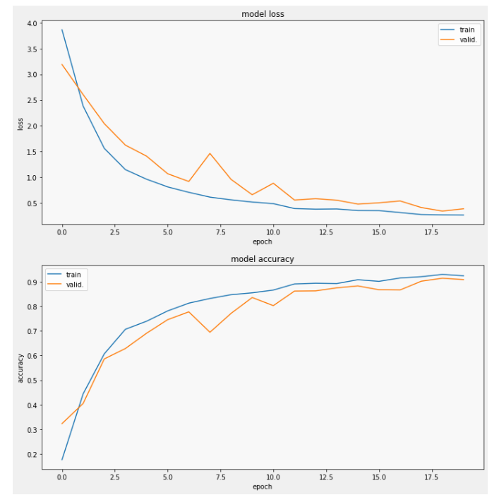**

**Figure 24**

*Confusion matrix for version 3*

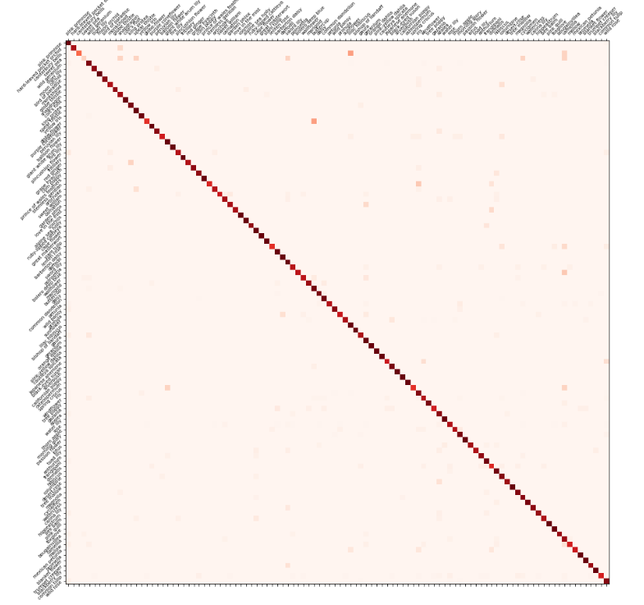

**Figure 25**

*Confusion matrix for version 4*

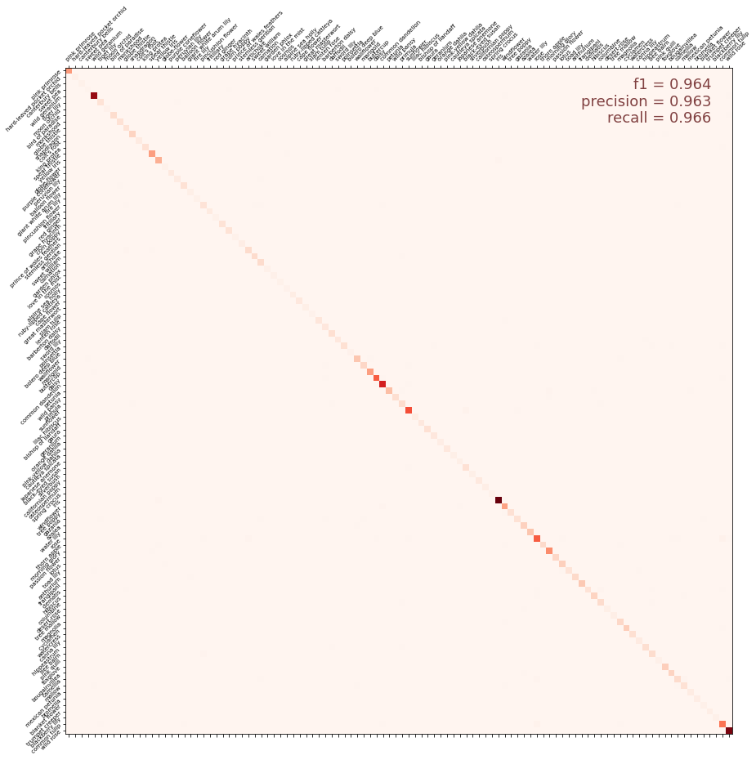

**Figure 26**

*Loss and Accuracy Curves of Version 5*

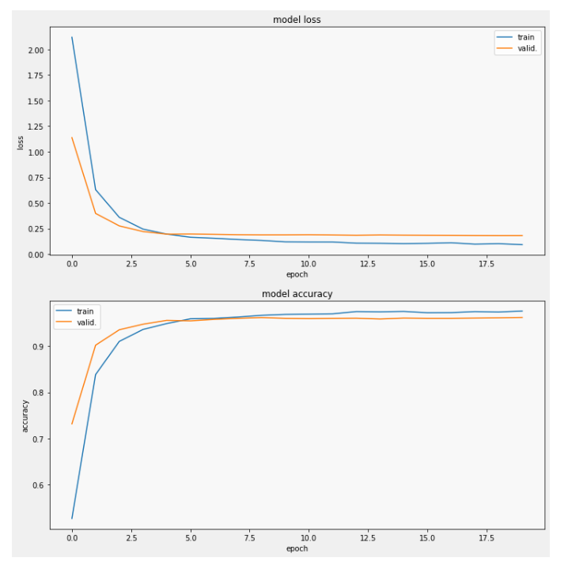

**Figure 27**

*Confusion matrix for version 5*

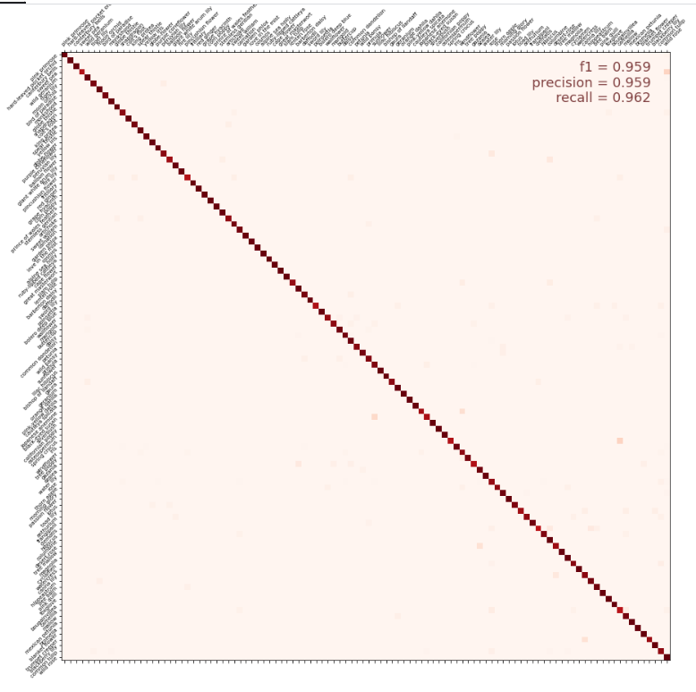

**Figure 28**

*Confusion matrix for version 6*

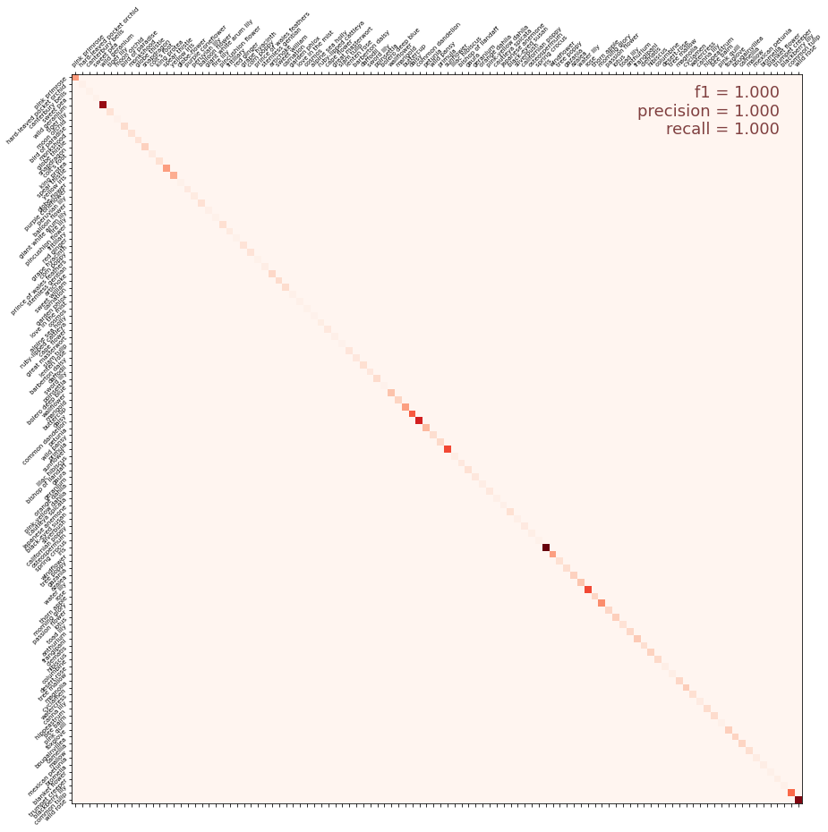

**Figure 29**

*Loss and Accuracy Curves of Swin Transformer*

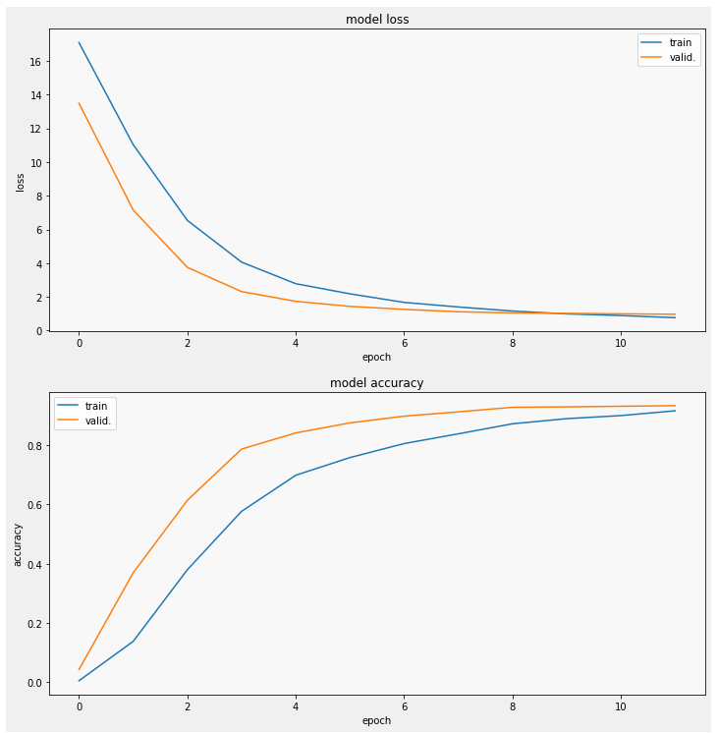

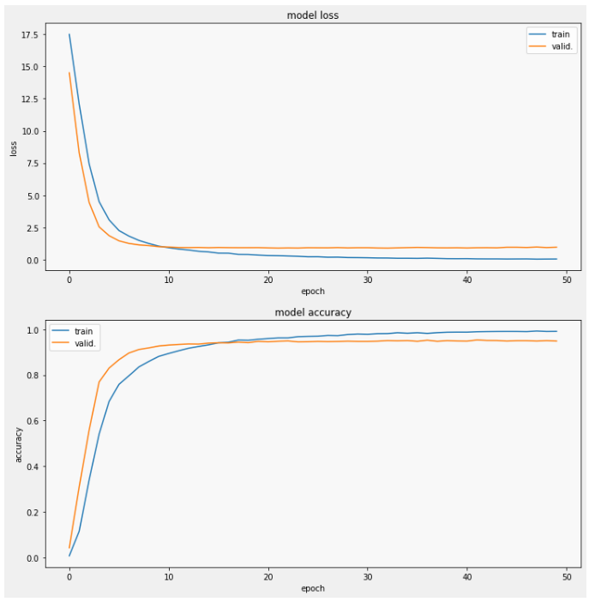

**Figure 30**

*Confusion matrix for Swin Transformer Version 1*

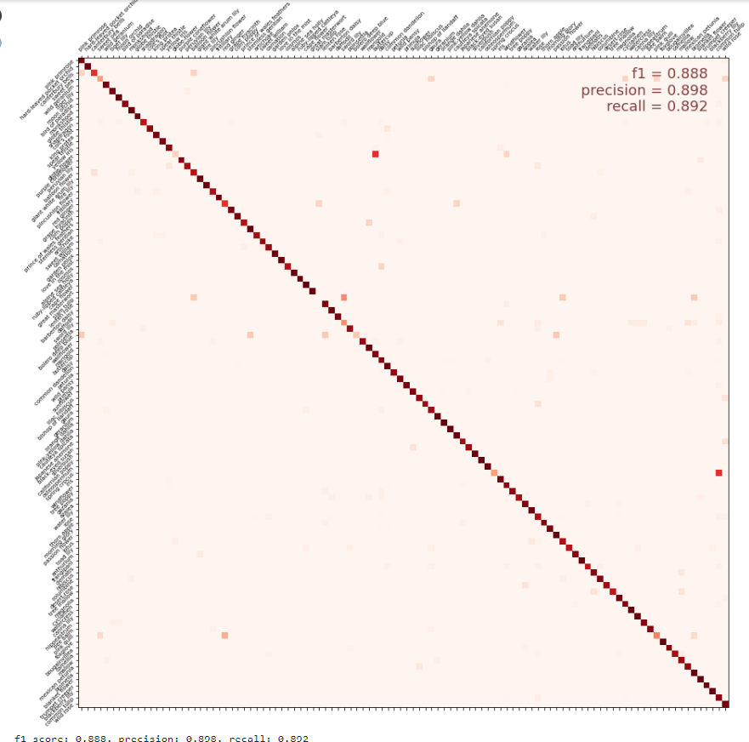

**Figure 31**

*Comparision of runtime for Vision Transformer on CPU and TPU*

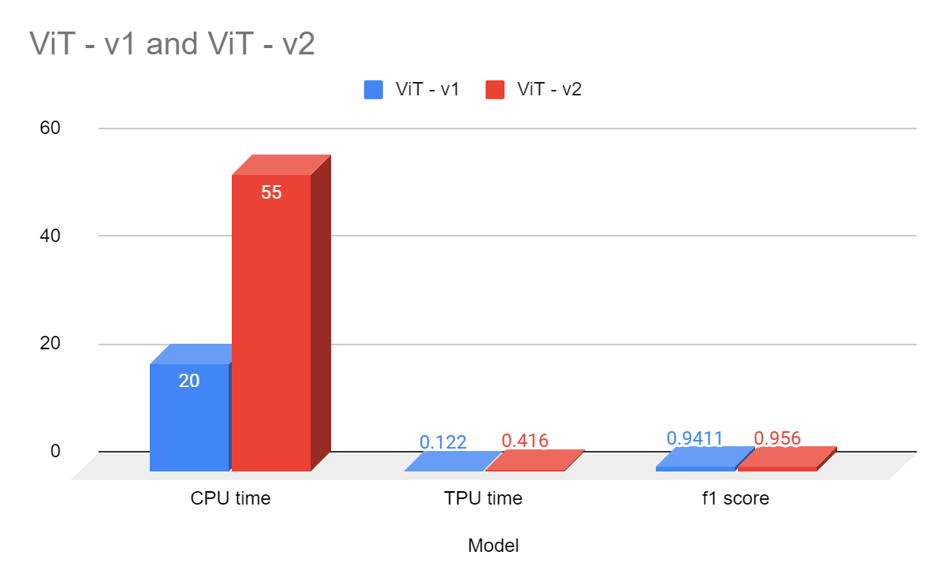

The TPUs perform way better due to Matrix Multiply Units.

**Figure 32**

*F1-Score comparison for all the models used.*

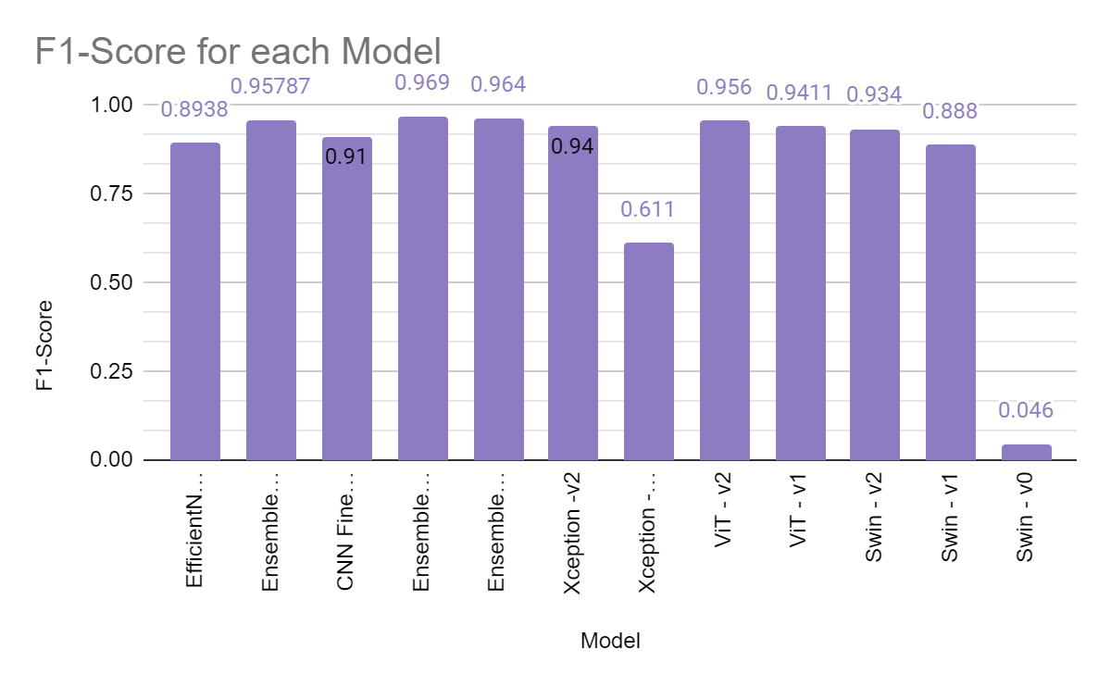

**Figure 33**

*Comparison of models based on F1-Score*

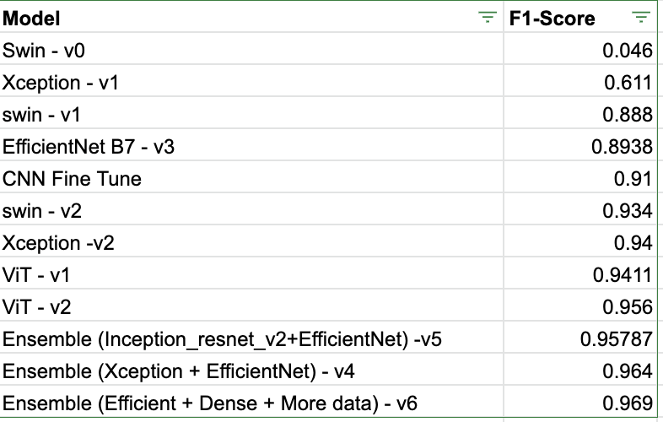

**References**

**Competition Link:** <https://www.kaggle.com/competitions/tpu-getting-started>

[1] N. Jouppi, C. Young, N. Patil and D. Patterson, "Motivation for and Evaluation of the First Tensor Processing Unit," in IEEE Micro, vol. 38, no. 3, pp. 10-19, May./Jun. 2018, doi: 10.1109/MM.2018.032271057.

[2] Xiaoling Xia, Cui Xu and Bing Nan, "Inception-v3 for flower classification," 2017 2nd International Conference on Image, Vision and Computing (ICIVC), 2017, pp. 783-787, doi: 10.1109/ICIVC.2017.7984661.

[3] Y. Wu, X. Qin, Y. Pan and C. Yuan, "Convolution Neural Network based Transfer Learning for Classification of Flowers," 2018 IEEE 3rd International Conference on Signal and Image Processing (ICSIP), 2018, pp. 562-566, doi: 10.1109/SIPROCESS.2018.8600536.

[4] Dosovitskiy, A., Beyer, L., Kolesnikov, A., Weissenborn, D., Zhai, X., Unterthiner, T., Dehghani, M., Minderer, M., Heigold, G., Gelly, S., Uszkoreit, J., & Houlsby, N. (2021, June 3). *An image is worth 16x16 words: Transformers for image recognition at scale*. arXiv.org. Retrieved December 6, 2022, from https://arxiv.org/abs/2010.11929

[5] Liu, Z., Lin, Y., Cao, Y., Hu, H., Wei, Y., Zhang, Z., ... & Guo, B. (2021). Swin transformer: Hierarchical vision transformer using shifted windows. In Proceedings of the IEEE/CVF International Conference on Computer Vision (pp. 10012-10022).

[6]E. Cengıl and A. Çinar, "Multiple Classification of Flower Images Using Transfer Learning," 2019 International Artificial Intelligence and Data Processing Symposium (IDAP), 2019, pp. 1-6, doi: 10.1109/IDAP.2019.8875953.

[7] Chen, Yunfeng, et al. “Classification of Lungs Infected COVID-19 Images Based on Inception-ResNet.” Computer Methods and Programs in Biomedicine, July 2022, p. 107053, 10.1016/j.cmpb.2022.107053. Accessed 6 Aug. 2022.

[8] Saukha. (2021, April 12). *Flower-CNN-efficientnetb7-aug-external-data*. Kaggle. Retrieved December 6, 2022, from https://www.kaggle.com/code/saukha/flower-cnn-efficientnetb7-aug-external-data/data

[9] Dosovitskiy, A., Beyer, L., Kolesnikov, A., Weissenborn, D., Zhai, X., Unterthiner, T., ... & Houlsby, N. (2020). An image is worth 16x16 words: Transformers for image recognition at scale. arXiv preprint arXiv:2010.11929.

[10] He, K., Zhang, X., Ren, S., & Sun, J. (2016). Deep residual learning for image recognition. In Proceedings of the IEEE conference on computer vision and pattern recognition (pp. 770-778).

[11] Huang, G., Liu, Z., Van Der Maaten, L., & Weinberger, K. Q. (2017). Densely connected convolutional networks. In Proceedings of the IEEE conference on computer vision and pattern recognition (pp. 4700-4708).

[12] Tan, M., & Le, Q. (2019, May). Efficientnet: Rethinking model scaling for convolutional neural networks. In International conference on machine learning (pp. 6105-6114). PMLR.

[13] Chollet, F. (2017). Xception: Deep learning with depthwise separable convolutions. In Proceedings of the IEEE conference on computer vision and pattern recognition (pp. 1251-1258)

[14] Szegedy, C., Ioffe, S., Vanhoucke, V., & Alemi, A. (2017). Inception-V4, inception-resnet and the impact of residual connections on learning. *Proceedings of the AAAI Conference on Artificial Intelligence*, *31*(1). <https://doi.org/10.1609/aaai.v31i1.11231>